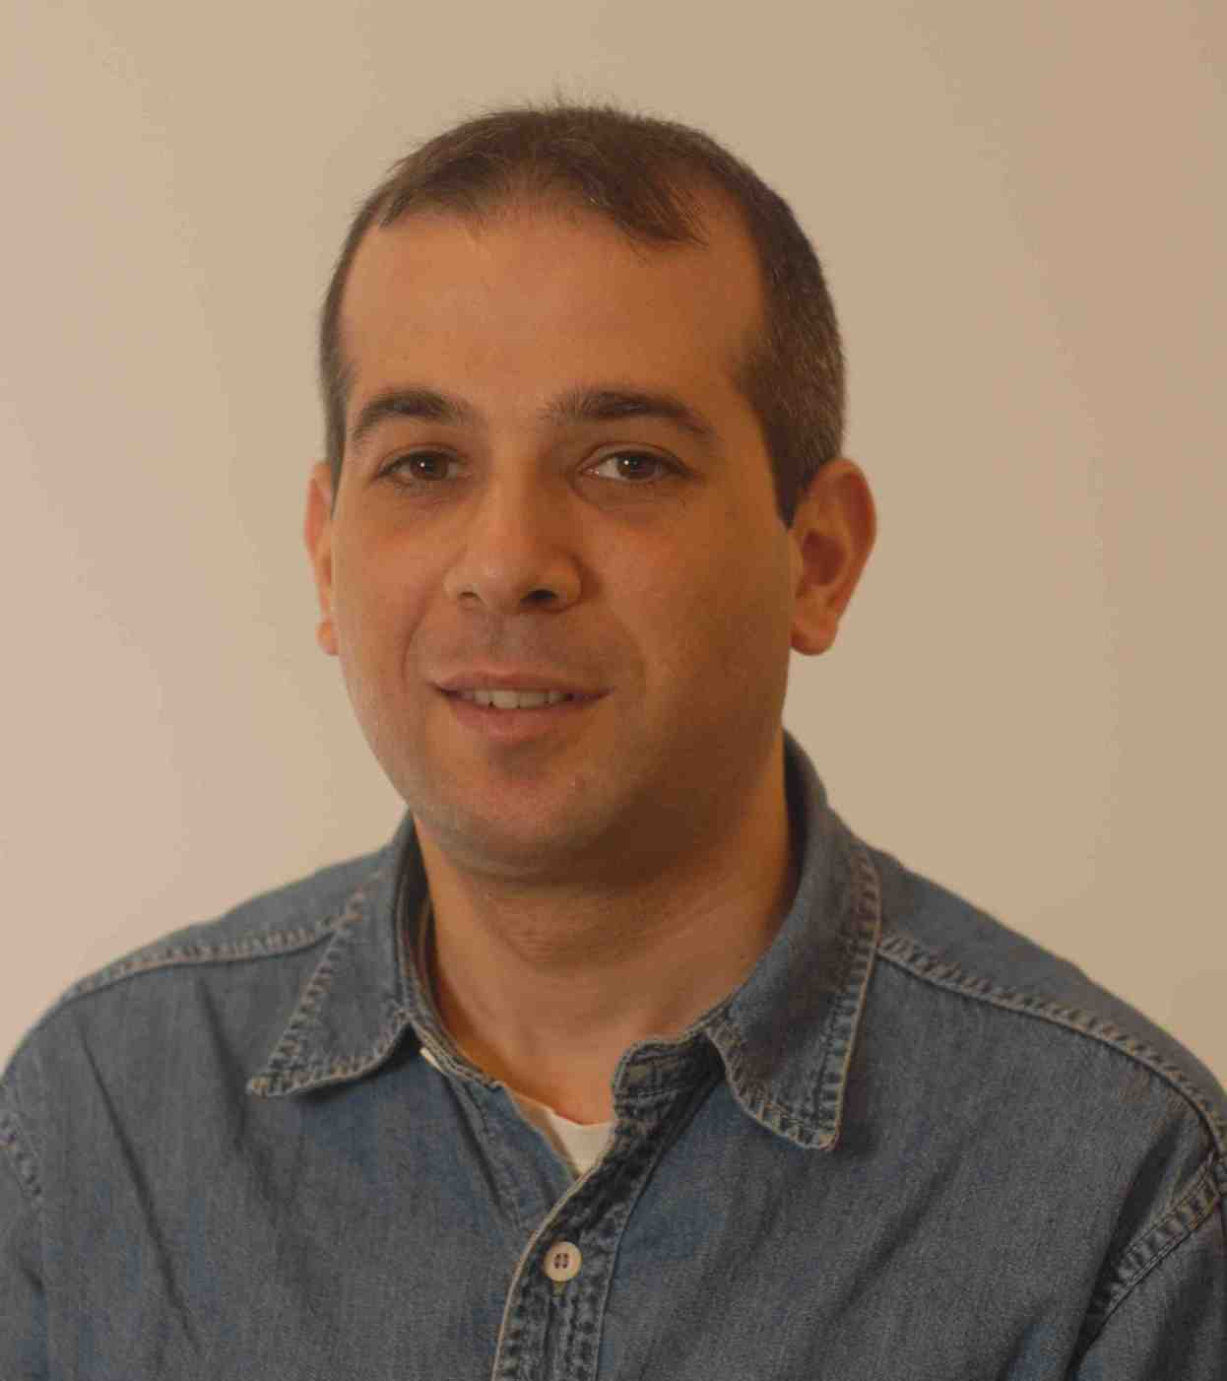

DR. YAMAN MUSDAL

EDUCATION
2006 - 2012 | Doctor of Philosophy | Hacettepe University, Faculty of Medicine, Department of Biochemistry  Thesis: The investigation of heterocyclic compounds as inhibitors of glutathione transferase P1-1 and evaluation the effects on human breast cancer cells.
2001-2004 | Master of Science | Hacettepe University, Faculty of Medicine, Department of Biochemistry  Thesis: In vitro DNA binding mode analysis of some benzimidazole and thiazolidindion retinoids
1996-2001 | Bachelor of Science | Ankara University, Faculty of Science, Department of Biology
TEACHING: Biochemistry laboratory courses to medical phase I and II and dentist students (4 years). Supervised several university/vising Erasmus students during postdoc studies.

RESEARCH
Jan 2020 - Lecturer/Researcher – Hacettepe University – Dep. of Pediatric Genetics
Oct 2013 - Sep 2015 | Postdoc Fellow - Stockholm University, Department of Neurochemistry
2006 -2012 | Research Assistant - Hacettepe University, Faculty of Medicine, Department of Biochemistry
Jan 2009 – July 2010 | Guest Student - Uppsala University, Department of Biochemistry and Organic Chemistry, Uppsala, Sweden
Jan – Mar 2008 | Guest Student - Sabanci University, Department of Biological Sciences and Bioengineering, Istanbul, Turkey

Selected Publications:
-Lindström H, Mazari M.A, Musdal Y and Mannervik B. Potent inhibitors of equine steroid isomerase EcaGST A3-3. PloS One, 2019; March. doi: 10.1371/journal.pone.0214160.
-Musdal Y, Govindarajan S and Mannervik B. Exploring sequence-function space of a poplar glutathione transferase using designed information-rich gene variants. Protein Eng. Des. Sel., 2017; 30(8); 543-49.
-Ertan-Bolelli T, Bolelli K, Musdal Y, Yıldız I, Aki-Yalcin E, Mannervik B, Yalcin I. Design and Synthesis of 2-Substituted-5-(4-trifluoromethylphenylsulfonamido) benzoxazole Derivatives as Human GST P1-1 Inhibitors. Artificial Cells, Nanomedicine, and Biotechnology (IANB), 2017; 14; 1-8.
-Musdal Y, Mannervik B. Substrate specificities of two tau class glutathione transferases inducible by 2,4,6-trinitrotoluene in poplar. Biochim Biophys Acta, 2015; 1850(9); 1877-83.
-Musdal Y, Hegazy U, Aksoy Y, Mannervik B. FDA-approved drugs and other compounds tested as inhibitors of human glutathione transferase P1-1. Chemico-Biological Interactions, 2013; 205; 53-62.
-Hegazy U, Musdal Y, Mannervik B. Hidden Allostery in Human Glutathione Transferase P1-1 Unveiled by Unnatural Amino Acid Substitutions and Inhibition Studies. Journal of Molecular Biology, 2013; 425; 1509-1514.
Meeting abstracts: ~30 poster/oral presentation abstracts in national/international meetings.
Involved Projects: Bioremediering av TNT-kontaminerade miljöer (2013-2015 - Carl Tryggers Stiftelse); Glutathione transferases i tumorceller (2015 - Swedish Cancer Society) ;

Research Skills: Professional in purification, enzyme kinetics and inhibition studies, modelling of proteins, directed evolution of proteins. Also experienced in cell culture techniques (MTT, cell proliferation and apoptosis using FACS), almost all molecular biology techniques (SDS-PAGE, agarose electrophoresis), basic microscopy and other tecniques.

Research Expertise/Interests: Enzymology, Structure function relationships of proteins, Inhibitors, Engineering of proteins for enhanced/novel functions, Directed Evolution and Modeling of proteins.

AWARDS; Carl Trigger Stiftelse postdoctoral scholarship (2014- 1 year). Best poster of the day. 27. Ulusal Biyokimya Kongresi, November 3-6, 2015, Antalya, Turkey

LANGUAGES: English - fluent, Swedish - intermediate

